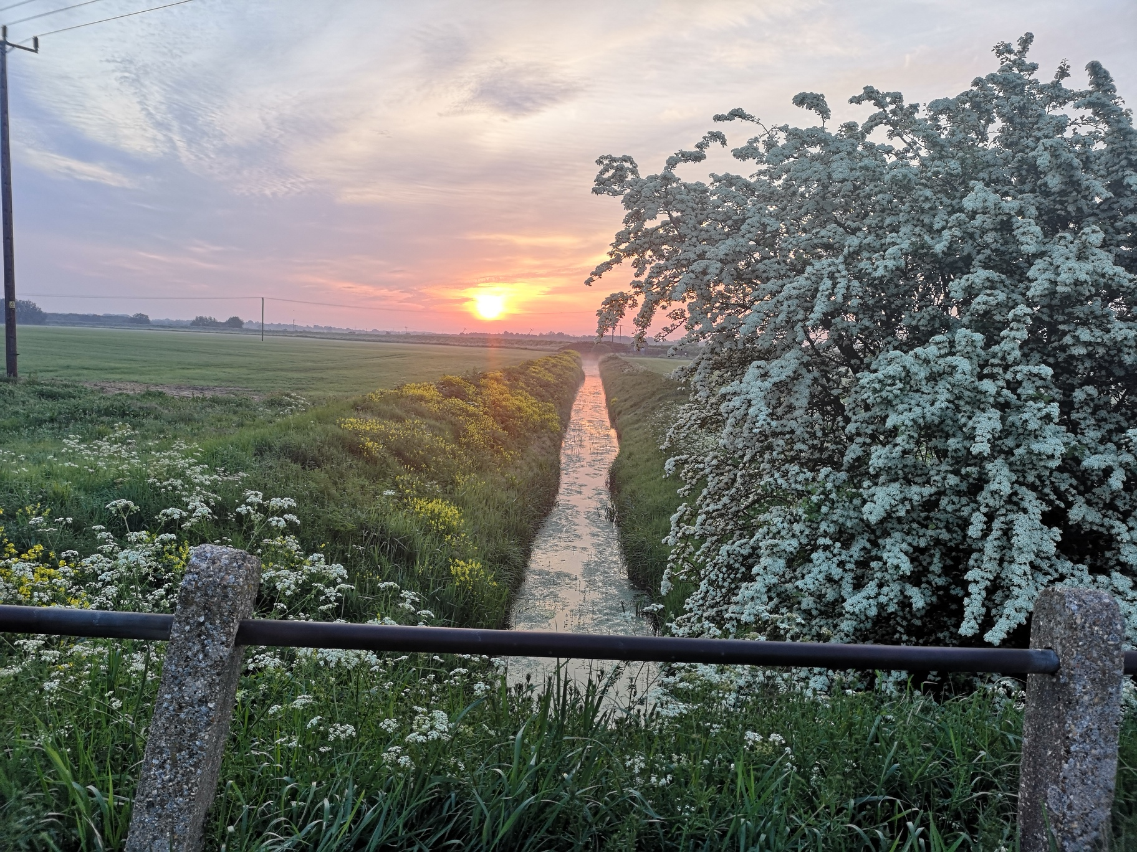
Water Care Partnership
Action Plan
Updated: May 2022

Project categories
- Water Care Partnership Project (WCP)
This is a project which the Water Care Partnership has either instigated, found funds for, facilitates, manages or has pledged support for. The project is usually delivered by a Water Care Partner, but the Catchment Partnership can influence its delivery/direction.

- Partner Project (PP)
One which a Water Care Partner is delivering (singly or in partnership), the project lead partner may update the Catchment Partnership, but the Catchment Partnership has little influence over project delivery/direction.

Other Related Project (ORP)
- A project which benefits the water environment but is not delivered by a Catchment Partner. This also includes projects which indirectly benefit the water environment.

Project confidence
- Confident of delivery (C)
A project which is already funded or has reasonable expectation of being funded, an agreed delivery method and location.

- Less Certain delivery (LC)
A project where there is there is uncertainty over funding or delivery, or a project where the action needed to improve a situation is not known.

Although the Water Care Partnership may not be able to influence all of the projects taking place in the Catchment it is an important role of the Partnership to understand what work is going on in the area which directly/indirectly affects the water environment in order to facilitate collaborative working across the catchment.

Project List: (update on various peat projects needed)
Project & category | Issue | Lead partner (s) | Confi-  dence | Progress to date | Next Action
Low Dissolved Oxygen in the R Delph  WCP | Ongoing work, funded by EA | EA | C | Abstraction licence applied for, pipes likely to be operational summer 2023. Freshening flow now created by opening Earith sluice gates. Options from Mott McDonald work now on FCERM capital programme. | MN to update partnership on EA progress.  Take to OW working group.
R Delph morphology and maintenance  WCP | Poor conveyance due to overgrown vegetation. RSPB WEG bid looked at conveyance. | EA plus shared input from RSPB, WWT, 100ft IDB | C | Resolution via Water Level Management Plan. Partnership must articulate effect on nesting birds, low DO, navigation. Fens GEP process to be considered. | MN to update partnership on EA progress.  Take to OW working group.
Cranbrook and Counter Drain Strategy  PP to be WCP | Need to develop wide ranging strategy for area around Block Fen/Langwood Fen gravel extraction sites - including flood risk, navigation, biodiversity. To be merged with Cambs CC Waste and Minerals masterplan. | EA & Cambs CC | C | Baseline reports commissioned. Future of Welches Dam uncertain – may need to keep it in place for time being. Many partners already involved in consultation. | MN/partners to update partnership on progress
Water Level Management Plan  PP | Set the WLM for the Ouse Washes going forward | EA | C | Mott McDonald appointed as consultants to lead on developing stakeholder engagement & options appraisal. | MN to update partnership on EA progress.  Take to OW working group.
River Care  WCP | Remove litter from Bury Brook/High Lode in Ramsey & Old Nene in March | RB/River Care | C | Canoe & kayak support for both groups. Ongoing picks. New equipment including life jackets from RiverCare. Good links with Fenland DC Environment team established. | Next picks: June 22
March Surface Water Flooding  WCP | Wet spots in March, encourage cohesive approach with stakeholders and greater community understanding/action. | CACRE | Funding applied for | Funding applied for from CaBA for engagement programme, Cambs CC and Anglian Water supportive. | If successful circulate bid round partners.
Preventing Plastics Pollution  WCP | Interreg project – reducing amount of micro and other plastics in R Ouse | Rivers Trust | Funding found but not applied for yet | Participated through RiverCare groups. New funding opportunity possible via CaBA for individual small projects | CACRE to write funding bid. Contact Fenland/Hunts DC.
Invasive Non-native Species  WCP | Other INNS: Mitten Crabs, Signal Crayfish, Zebra mussels sp. and Himalayan Balsam | RB to provide secretariat, rotating Chair | LC | Floating Pennywort project completed.  Mitten crab & Signal Crayfish identified as main threats. | RB investigate Mitten Crab control, KA present paper on Signal Crayfish control. Take to working group.
School engagement  WCP | Need to “catch young people” to help them understand value of water environment. | RB/MLC | C | Eels in the Classroom project working in two school, potential to run project with more schools next year. | Deliver project, if successful consider roll out next year.
Local Authority engagement  WCP | Need to let Councils know of our existence, what we can help them with, importance of water environment. | RB, any other partners | C | Better links with Cambs CC, Fenland & Hunts DC. Meeting Swavesey PC. | Continue with newsletter, Linked IN.
Catchment sensitive Farming/agriculture in general  WCP | Reduce rural diffuse pollution, understanding what the future holds for farmers now re. funding | NE | LC | New CSF Officers contacted. | Involve in agriculture working group
Catchwater Drain NFM  WCP | Slow the flow of water off “highlands” into Catchwater drain. | MLC (if interested) | LC | MLC interested if funding opportunity arises | RB/MN to contact MLC if funding available
Fens GEP  WCP | Improved overall biodiversity and achieve GEP on drains/ditches . Ties in with MLC biodiversity work | EA/MLC | LC | MN keen to trial on a waterway, possibly Delph. | MN to keep discussing with EA. Wait until new MLC conservation Officer in place and meet to discuss.
Bury Brook: water quality assessment & morphology  WCP | Lots of small WRC’s feeding into the river contributing to high P levels and low DO levels. Because of the size of the WRCs major investment from Anglian Water investment unlikely – could investigate the possibility of small wetlands to remove P | Unsure, need involvement of Anglian Water, Town and Parish Councils and Ramsey River Care. | LC | None | No support form partners yet. Consider at Water Quality working group
Ouse Washes WEG  PP | Improving conditions for the Ouse Washes breeding birds, especially mitigating against minor spring flood events | EA/MLC/RSBP | C | Next steps dependant on funding application via IDB | DT to co-ordinate meetings to discuss
Ouse washes habitat creation project  PP | To mitigate against the decline of suitable habitat for wetland birds on the Washes | RSPB | C | Delivery of habitat at Coveney is slow, currently only 125Ha of functional grassland created through rapidly successful colonisation of target wader species. | Final phase of Coveney to be delivered by 2023, Sutton site to be formed soon.
Project Hereward  PP | Restore the navigation link between the Middle Level and the Great Ouse; Restoration of Horseways Channel and Welches Dam | IWA | C | Cambs CC assurance that water retention of Forty Foot built into new Minerals and Waste Plan | RS to update partnership on progress
Wet Farming on Great Fen  PP | Carbon sequestration, new crops, news ways of farming and water use | WTBCN | C | Land prepared, first plantings going in Sept 20 onwards. Project got funding extension; sphagnum moss being planted. | No action needed
Great Fen  PP | 50-year project to create a huge wetland area and join Wood Walton Fen and Holme Fen which are National Nature Reserves | WTBCN | C | New funds from HLF -8 million for peat farming | No action needed
Destination Denver  PP | Increased mooring, improved facilities, improved access & interpretation | EA Navigation | C | New moorings built, facilities upgrade, cycle sheds, looking at café and more moorings, wild area to be planted. | None
Fens Biosphere  PP | Achieve UNESCO Biosphere designation for Fens | Cambs ACRE until Mar21 | C | Programme manager left, consultant visited LAs. Some Local Authorities support still not obtained | None needed
Future Fenlands  ORP | Deliver a long-term solution to the drought, coastal inundation and flooding related risks which are posed by climate change the 2021 as one of the key Gov’t initiatives to tackle flood risk and carbon & related issues such as food security. | WRE | C | Initial workshop – Oct, wider stakeholder workshops Nov/Dec 20. | Catchment Partnership may attend wider workshop , partners most likely will.
Doubling Nature  ORP | LNP - aim to double amount of wildlife habitats and natural greenspace in the County by 2050 | Natural Cambridgeshire (LNP) | C | Doubling Nature pledge launched, Nature Recovery Toolkit drafted | none

Relevant Local Partnership/Initiatives which Water Care partners contribute to

Initiative | What is it?
Natural Cambridgeshire | Local Nature Partnership
Fens for the Future | Conservation partnership
Lowland Peat Pilot | NE led pilot study
Ouse Washes Land Managers meetings | Not meeting at moment – discuss with NE
Water Resources East | Partnership funded by EA/Anglian Water to address regional water resource strategy
Fens Waterways Link | IWA: now Boston to Peterborough Wetland Corridor, Linking Lincolnshire and the River Witham with Cambridgeshire and the River Great Ouse
Anglian (Gt Ouse) Regional Flood and Coastal Committee | Managing government investment to reduce flood risk and coastal erosion in England.
Future Fens | EA and partners developing report on Future of flood risk management in Fens
Fens Water Partnership | Anglian Water/Mott Mac Donald scoping exercise for new reservoir
Anglian Water DWMP | Drainage & Waste water Management plan – input from catchment re waste water treatment.

